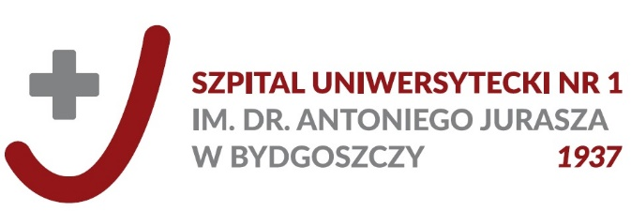

Information clause

Dear Patient,
Pursuant to art. 13 of general directive on personal data protection as of April 27, 2016 (Official Journal of European Union L119 as of 04.05.2016) I inform that:

- Administrator of personal data is The Dr Antoni Jurasz University Hospital no. 1 in Bydgoszcz.
- Personal data shall be processed due to process of providing health services, including handling medical documentation as well as in order to ensure health care and managing the systems and services of health care and health prevention.
- The recipients of personal data shall be exclusively entities entitled to obtain personal data on the basis of legal provisions or implementation of health services indicated among others in the Act on patient’s rights and Patient’s Rights Spokesman.
- The period of storing personal data included in medical documentation drawn up in a paper form is specified by the Act on Patient’s rights and Patient’s Rights Spokesman (detailed periods of storing medical documentation are mentioned on www.jurasza.pl in the folder Patient’s Guidebook).
- You are entitled to demand from the administrator to have access to personal data or to correct it.
- In case of deeming that your rights have been infringed, you may bring in a complaint to a supervisory body - President of Personal Data Protection Office.
- Providing personal data is obligatory on the basis of provisions of the directive on personal data protection as of April 27, 2016 (Official Journal of European Union L119 as of 04.05.2016.
- Contact data to Inspector of Personal Data Protection:
- Data Protection Officer - Jerzy Nowak
- Deputy Data Protection Officer - Joanna Jasińska
e-mail: iod@jurasza.pl

